**AWS Task-3**

**Task Description:**

1. Create a S3 bucket, with no public access and upload files to the bucket & view the logs using cloudwatch for the uploaded files.

**Created S3 Bucket with no public access:**

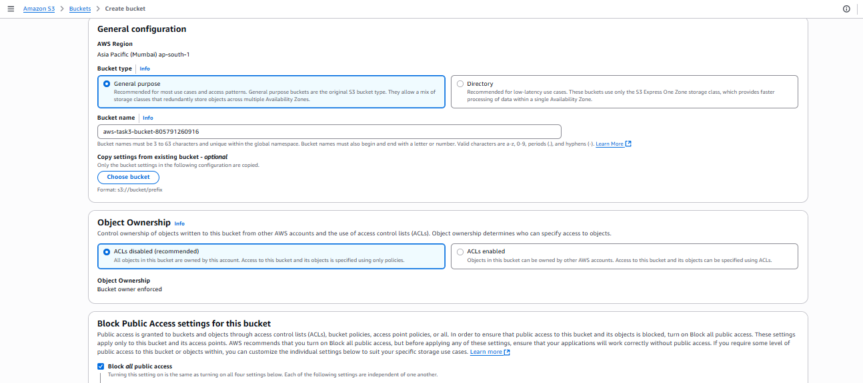

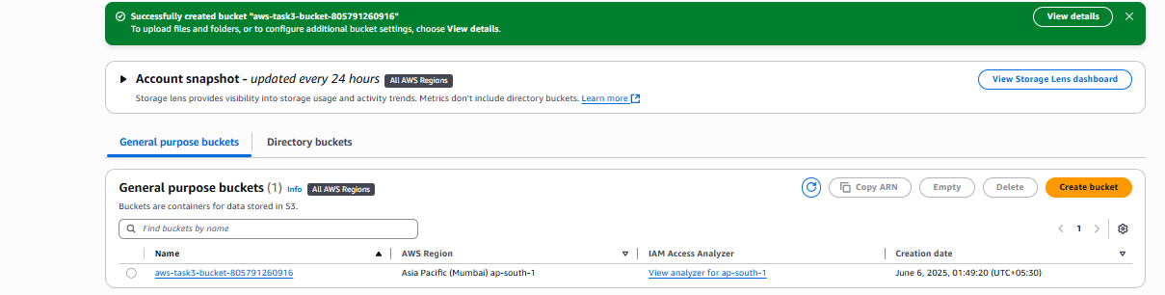

**Uploaded Files to the bucket:**

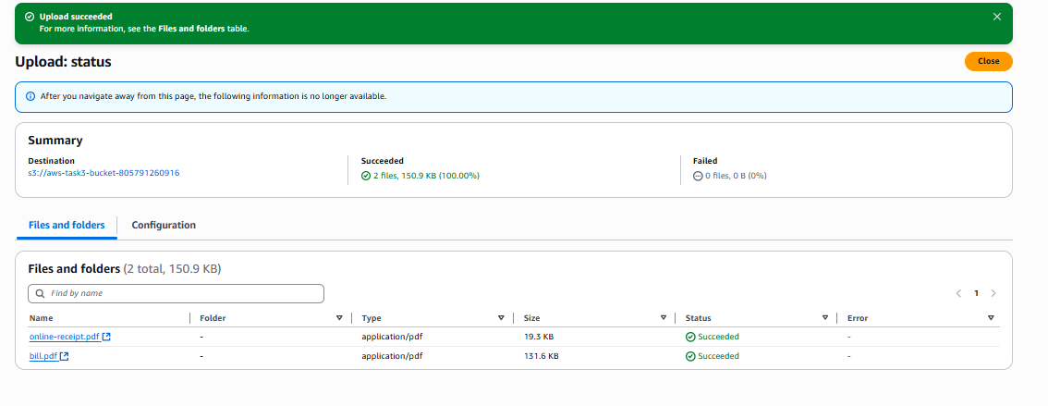

**View the logs in cloudwatch log streams:**

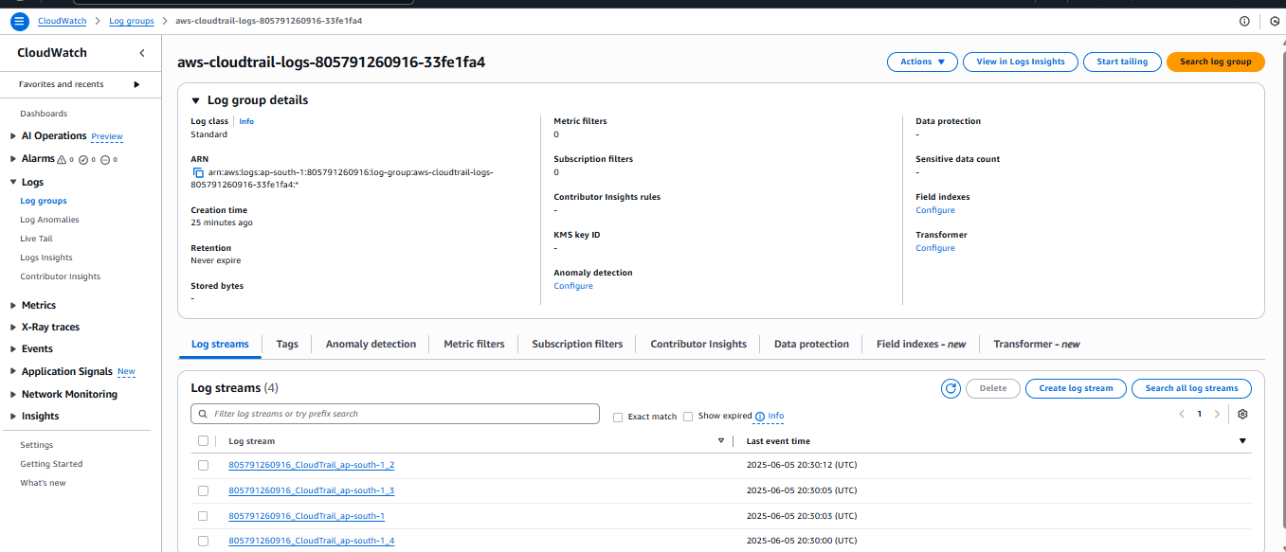

1. Launch two ec2-instances and connect it to a application load balancer, where the output traffic from the server must be an load balancer IP address

**Created 2 instance with apache web services mentioned to install apache service in user data option**

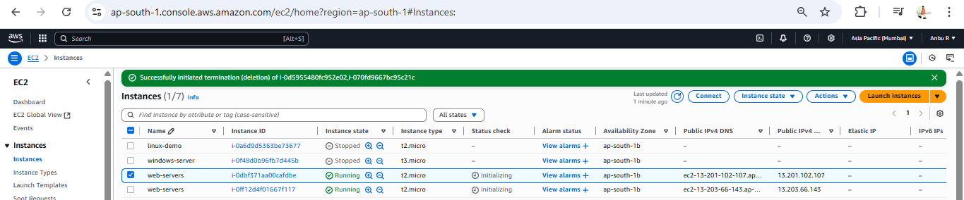

Target group created with instance of webservers:

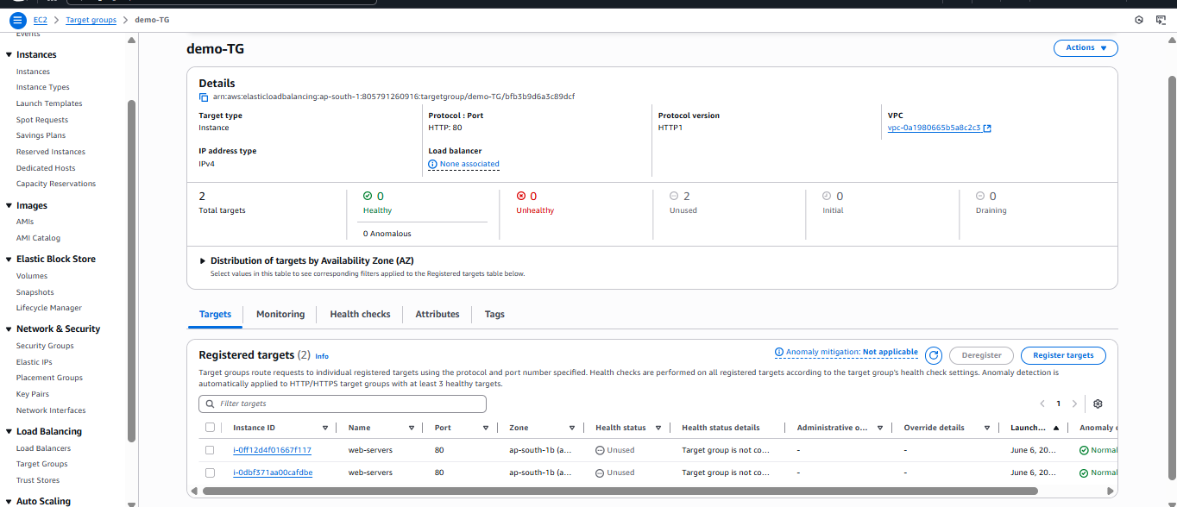

Created Security group:

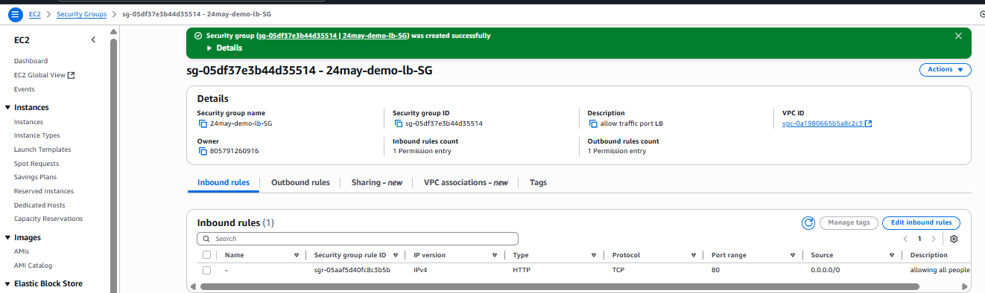

Created Load balancer with target group and our security group

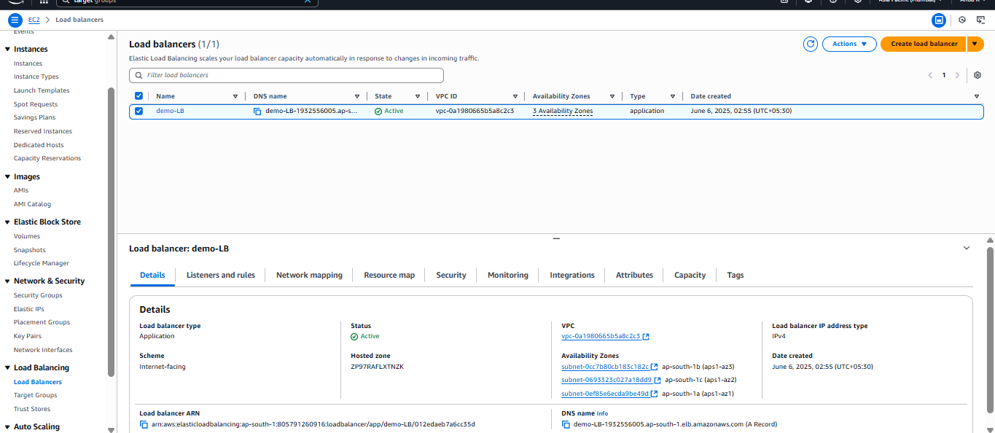

**Verified with DNS name of load balancer details and it is working:**

